Humane dekha tha ke mauryaotaar kaal me haum rajon ko do tareek se baat skte hai
1 deshi shashak indegenious ruler jisme sunga kanva, sathvanas etc
2 vedshi shahsk forieng rulers indo Greek , scythians parithan
Hind unane,bolo indo Greek bolo, ya indo bacteria bolao sam hai , hind yavan sab ek hai
Parthian, pahlav , \kushan

Note milindpanho achayra nagsena ne he likhe hai philospical discussiotn between milin and nagsena has describe in milindpanho me kyia gaya hai
Isme likha hai ki kaisw Milind nagsena se prabhavet hote hai aur buddhsim ke or unka jhkaov ho jata hai buddha dhamr ko apna lete hai
q- kisne Milind ko buddha dahamr ke dekhnsa Dilwar the to answer nagsena
to pure indo Greek ruler me Milind bahut mahan shahsk tha

shak ke bare me intretisng bat ye hai ki ye panch alag alag shakahon me bahrat aye the ye central asia wale region se india aee the to 5 alag alag shakahon me ye bharat aye the ek shakah bhar he rah gae aur char shakaey bharat aee the
to fir inko bhe do bhago me bata gayay kuki inke pradali ko chatrap kahte the
1 bana uttare chatrap jisme taksheela and Mathura ke chatrap the
2 bana paschimi chatrap jsime nasik and Ujjain ke shak sahhsk shamil the
Bharat mejo sabse Jayda prashedh hue wo the Ujjain ya Malwa ke chatrap jisme rudradaman sabse mahtvapuran rajaj hua tha
Aur rudradaman shako ke kardamak aur chasten naamk vansh se ata tha
Nasik me charahat vansh ka shashk tha ye bhe chatrap the shak
Nasik- charahat- shakas dynasty= nahpan
Ujaain- kardmak, chasten- shakas dynasty – rudradaman

q- gondofernise ka sambadnh kis vansh se hai to answer pahlav se Parthian se

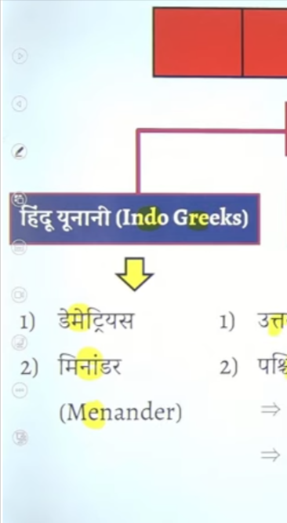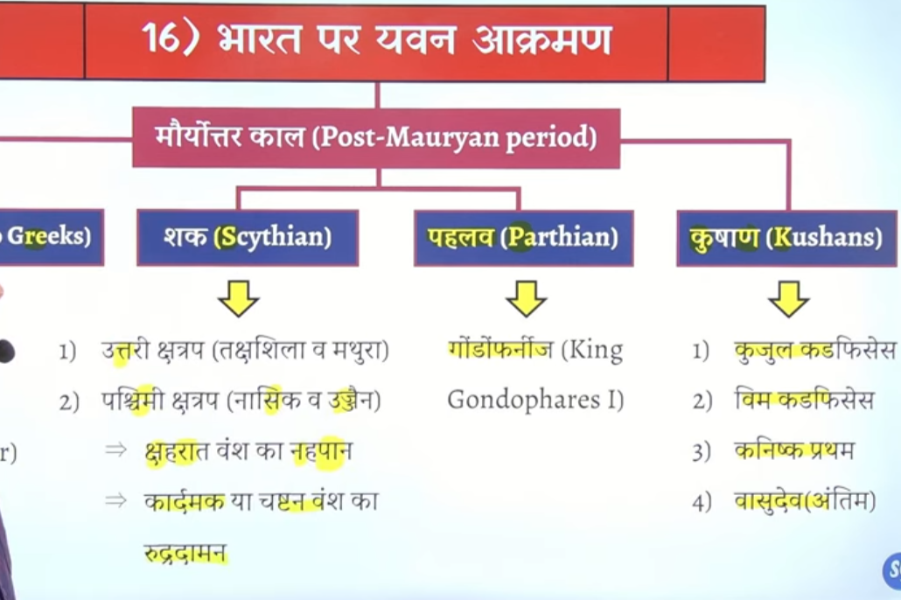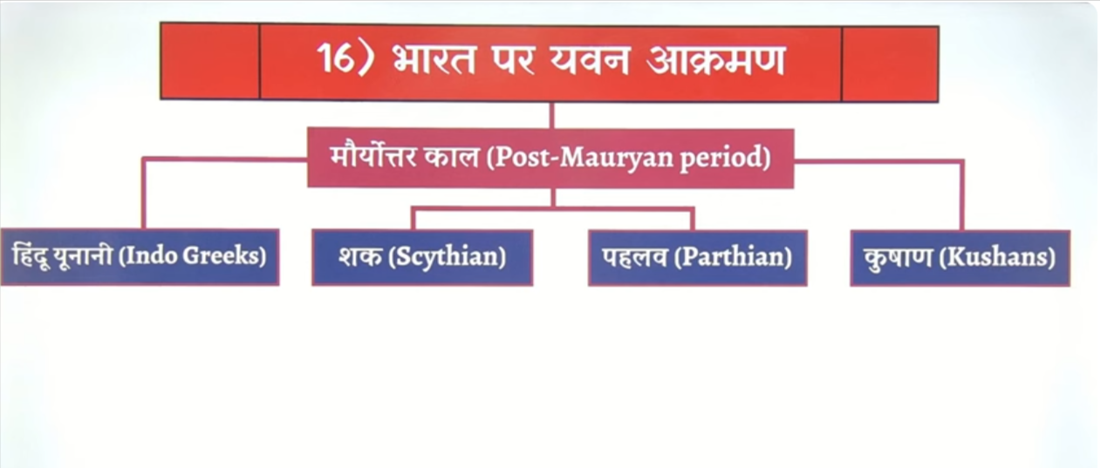

Indo Greek ko hind yunane ya indo bacteria rulers bhe kahah jata hai
Aisa ku
Indo greke kejankari hume sikko se milte hai kuki yahe se inda me vayvasteht roop se chalna sehuru huet the
Bharat me gold coin to parsian se chale the derik naam ke mudra the jo persian ne chale the lekin unka prabhav bharat ke bahut sare chetro per nahe tha iskley
Historian aisa mante hai ki bharat me regularly ya vyavasthet roop se gold coin chalane ka sherya hind yavan shahsko kojate hai sone ke sikke chalane ka sherya indo Greek ko jatya hai india me systematic roop se gold coin ko issue karne ka credit hai wo indo Greek ruler ko jata hai
Ye sikko per rajaj ke image bhe bante the gold ke coin per king ka image inscribe karne ke trend ko start kyia tha indo Greek ne
So indog Greek ke rule ke information hume coins se , ,malikaagnimatram , gargi samhit se milte hai

326 Bce me jab sikandar ne bahrt per akraman kyia th yahe se bharat and Greek ke beech sampark ke Shurat hote hai communication establish hota hai ane wale ke kafi time tk ye connection bana rahega jb tk waha isalam ka uday nahi hota fir ottoman empire nahi banta hai
Utne lambe samya tk Greek ke sath bharat ke bahut ache sambandh rahenge fir isse kram me Greek india per attack bhe karte rahenge
Sikandarer jb gyay tb baad me celus nicator wahah yaa tha india wale regime me
Celus nicatoer ke ssuccesor bahtu weak the aur uska ek pota tha antiocus second ke samya per uska smarajyd tut kar do bhago me batt jata tha
Ek hissah bacterial kalhlata hai jo afganistan wale Chetra me the north west india
Ek hsisa Parthia kalhat ahia jo iran and irak wale elake me isthapeet hua tha
Isse bacteria vansh ke sahaahk ka naam tha Demitrius isne 190BCE mme bharat per akram kyai aur yahe se bharat me indo Greek rule ke start hue the 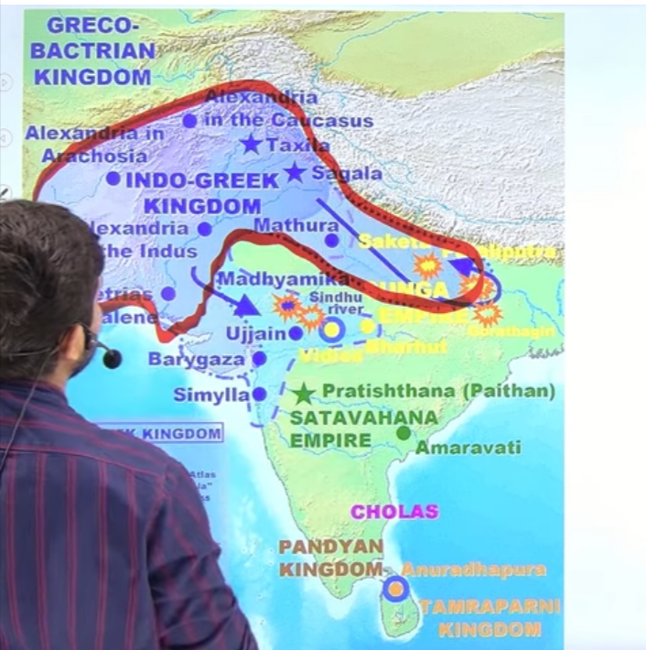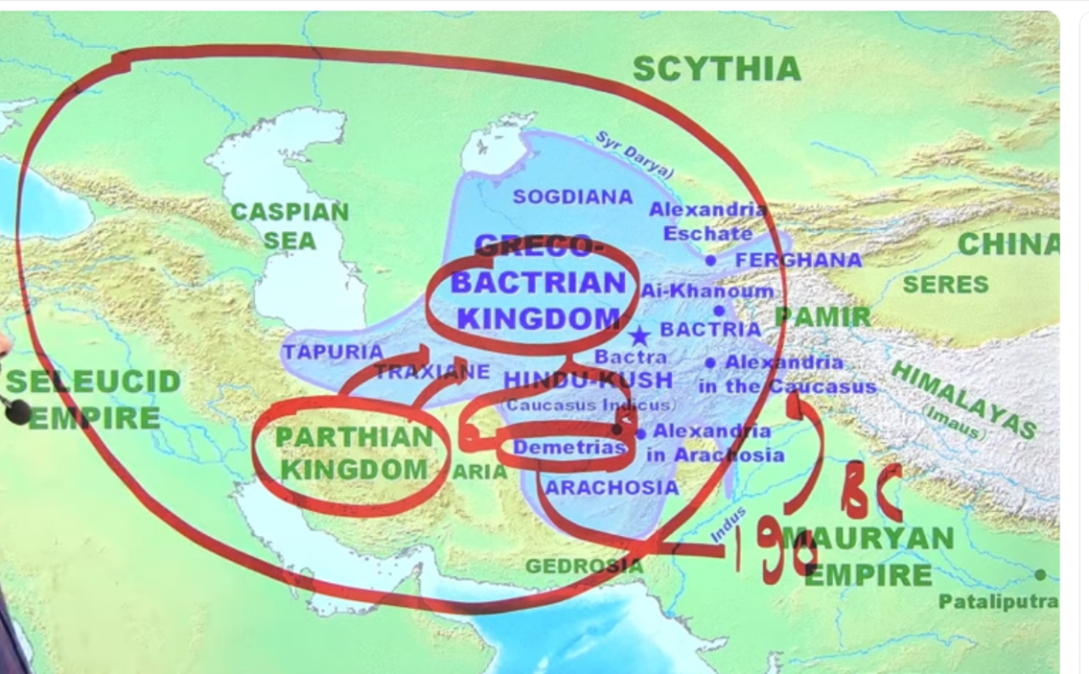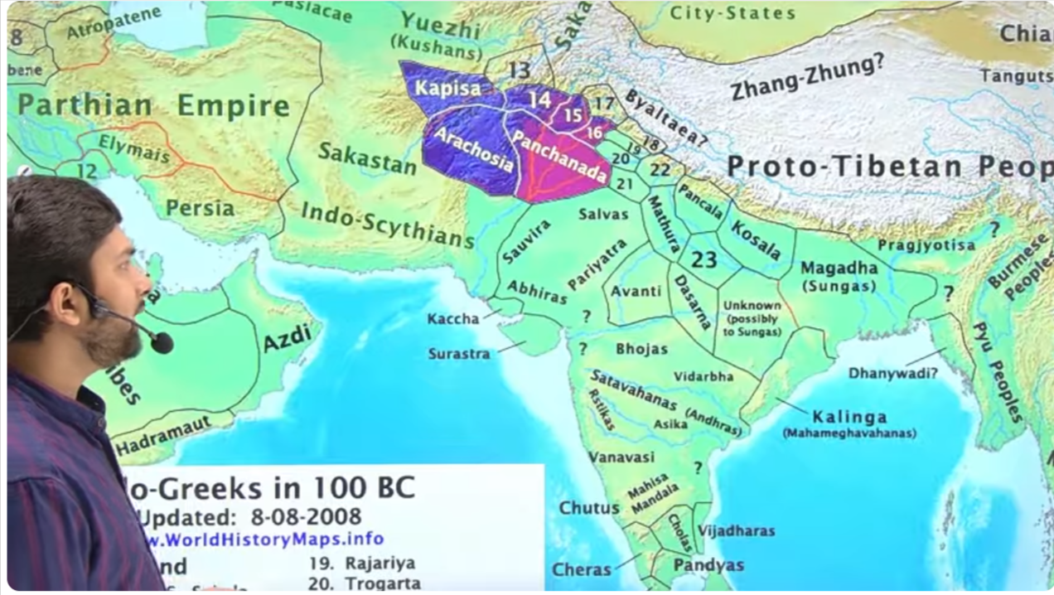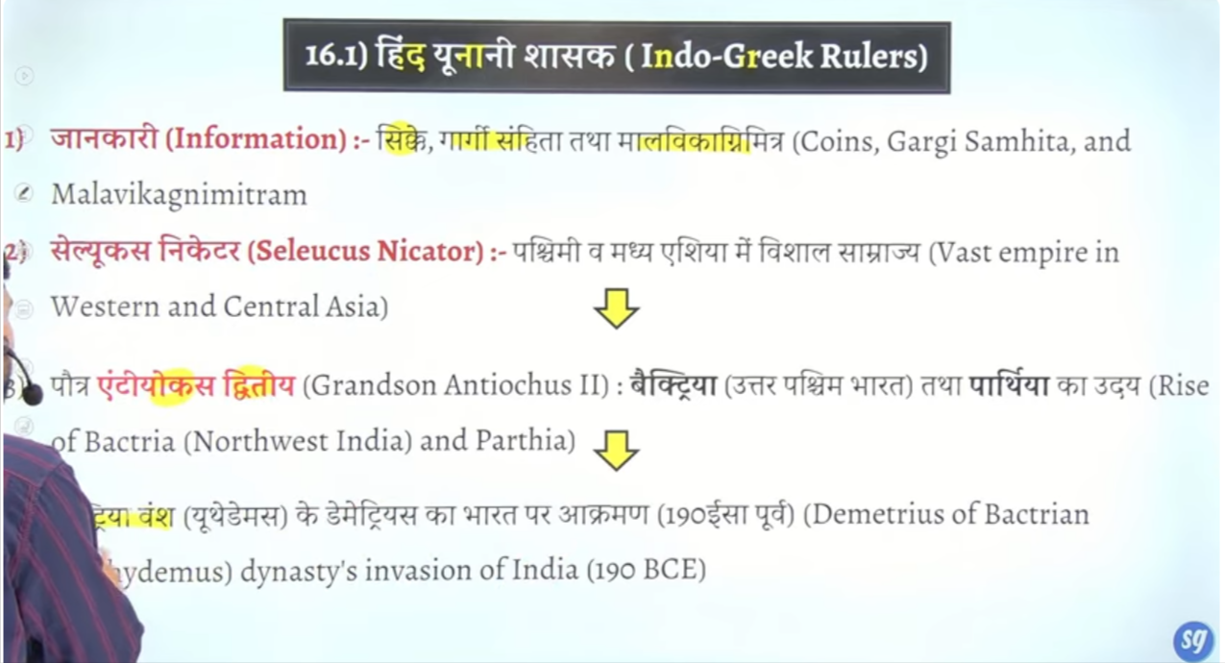

Ye bahtu bada ilaka celus nicator ke rajvansho kebad tha fir jb celus nicator kthm hoo gya Mauryan khtm ho gaye tb yaha do chote chote rajon ke utpate hue the ek tha Parthion aur Dusra tha Bactarian kingdom
Bactarian kingdom ke bhe do alag alag branch banege isme he ek rjaj tha demitriis jisne 190 bc me india per attack kyia tha
Yahe se indo bacterian rule ke starting india me hue the
Fir cythian and Parthian bhe bharat per attack karenge fir Kushan ayenge wo bhe bahut lambe samay tak bharat per shahasn karenge
You can see ingo dgreek ruler kindgon In map
Inke capital the cyalkot

To Jo idno Greek dynasty hai isme bhe do branch hai
Ek branch ka naam hai demitrus ya uthdemus second is ukredities branch
Utehdemus king ke name per he is kingdom ka name pada uthedemus first king tha
Demitrus jisne india per attack kyai
Menasnder sabse famous ruler
And last is strato isne lead ke sikke jare kyia tha

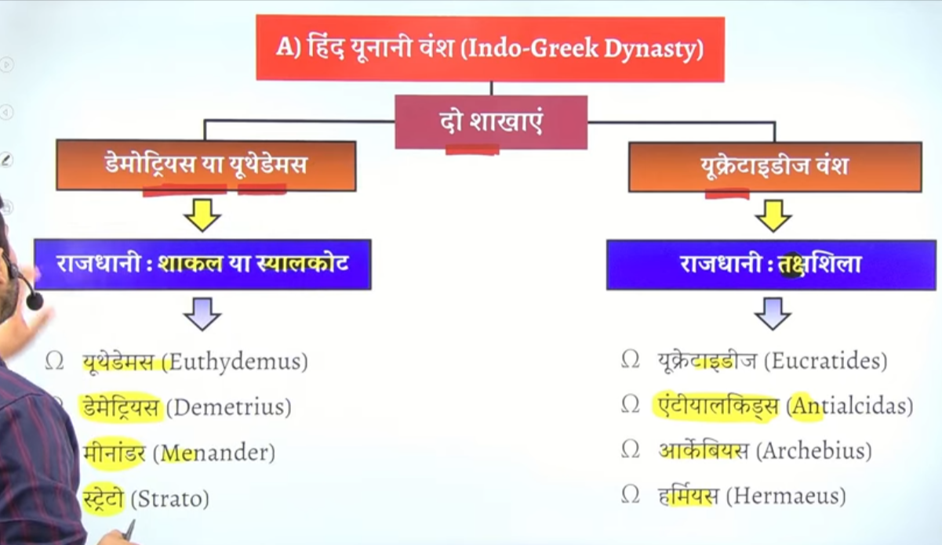

Ukredidsu vansh me
Antialicidas name ke king ka jb bhagbhadr naam ke rajaj ka shashan chal rahh hot ahi Vidisha besnagar Chetra me shung vansh ke rjaj ke time per us time per ata hai
Us time per antiacidas ka rajddoot heliodorus atat ahi heliorir su bhagvat dharm ko apnata hai aur aur garun isthamb ke isthpana karta hai
Inka itne he importance the
Sirf main hai Menander

1 is demitrus first 190bce me sabse pahle isne he bharat per attack kyai tha afgansitan Punjab and Sindh are ma aur ye jo ilaka tha isko he bacteria kahah gyaya tha
Isne bilinguial coin bhe chalae the jo gke Greek and Kharosthi langaue me likehue the isme pane capital shakal ya shayalkot ko banayay tha
q- kis indo Greek ruler ne bharat per akraman kyia tha frist to demitrus
indo greeq k ruler ke capital kya the
answer shakal ya syalkot
inka jo mahan rjaj tha wo tha Milind jisko minander bhe bolte the
2 heis famour and renouwned ruler tha
Ye Shurat me buddha dharma konahie matna tha btu later one nagesna ke saht bahut lamba philophical discussion hota hai jiske baad milindp ne buddha dharma ko apna lyai tha ye pure kahne milindapnho me likeh ahi

Si coins are the major source to know about the indo Greek ruler
Kuki indog reek ne sikko per first tim image ko incsive karna start kyai tha

Milindpanho kiski book hai achyara nagsena ke
Kis ruler se judhi hai to menander se

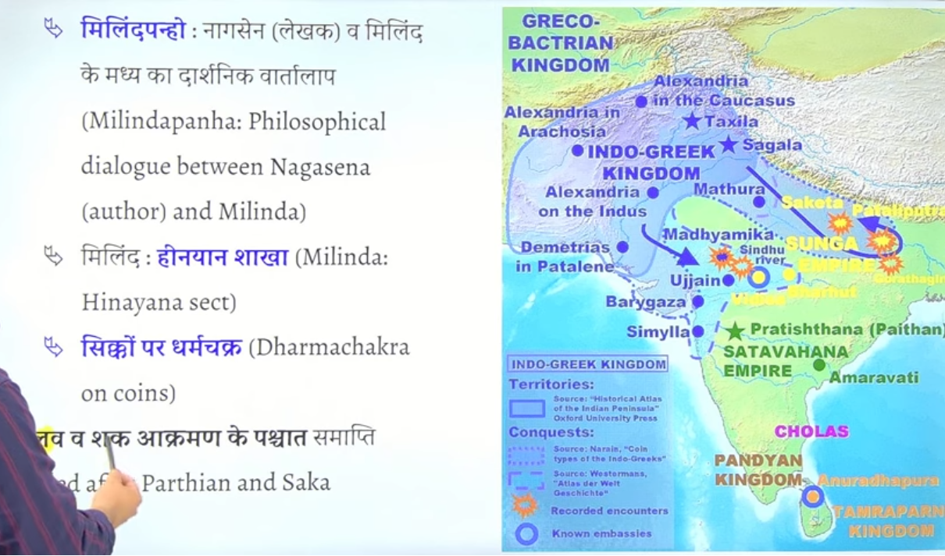

Pahlav and shako ne akraman kake inko khtm kar dyia tha

Inke prabhav

Helinsicit art bharat ayay tha helinstic art Greek ka art tha jisme wo painting aur muryain banate the
Q bharat me indo Greek ruler ke karna kaun se kala art ka vikas hua tha
Anse: helinstic art ka
Issek helinstic art se age jakar ke Gandhar kalaart ka develompnent hota hai
Bharat me natak me pard eke shrut bhe indo Greek se aye hai isko yavanika bote the
Yavanpriya kali mirchi
Barat me pard eke prachna ke shruta indo Greek ne ke
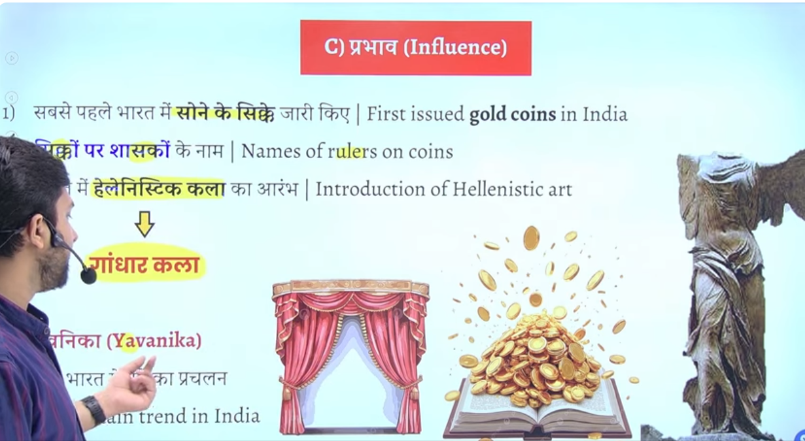

Demetrius I (reigned c. 205–171 BCE), son of Euthydemus I, is widely considered the first Greco-Bactrian king to invade and establish the Indo-Greek kingdom in the Northwestern Indian subcontinent around 180 BCE. He was known for his expansion into India, often represented with an elephant-crown on his coins.
Wikipedia +4
- Founder: Demetrius I.
- Background: He was a Bactrian Greek who expanded his kingdom across the Hindu Kush into Gandhara and Punjab.
- Significance: His conquests initiated the Indo-Greek era (c. 180 BCE–10 CE), which saw a blend of Greek and Indian artistic traditions (Gandhara School).
- Other Key Figure:
While Demetrius I was the first to invade, Menander I (165–130 BCE) is known as the most significant, famous for his conversions to Buddhism (Milinda Panha) and extensive conquests.

Testbook +4

To Who issue first time gold coin in india ?

The Indo-Greeks were the first rulers to issue gold coins in India, starting around the 2nd century BCE, often featuring the name, title, and portrait of the king. However, the Kushana dynasty is recognized for issuing gold coins on a large, regular scale in India, particularly under Vima Kadphises and Kanishka I.
Key Details on Early Gold Coinage in India:
- Indo-Greeks (2nd Century BCE): Known for issuing the first known gold coins, notably under kings like Menander I, which were influenced by Hellenistic styles.
- Kushanas (1st Century CE): Often cited for initiating the first widespread or large-scale use of high-purity gold coins (
Dinaras or Suvarnas) in North India, heavily influencing the economy.
- Significance: While earlier, smaller forms of gold currency (like Nishka) existed, the Indo-Greeks and Kushanas introduced structured, regal gold coinage.

Schythina Shakas

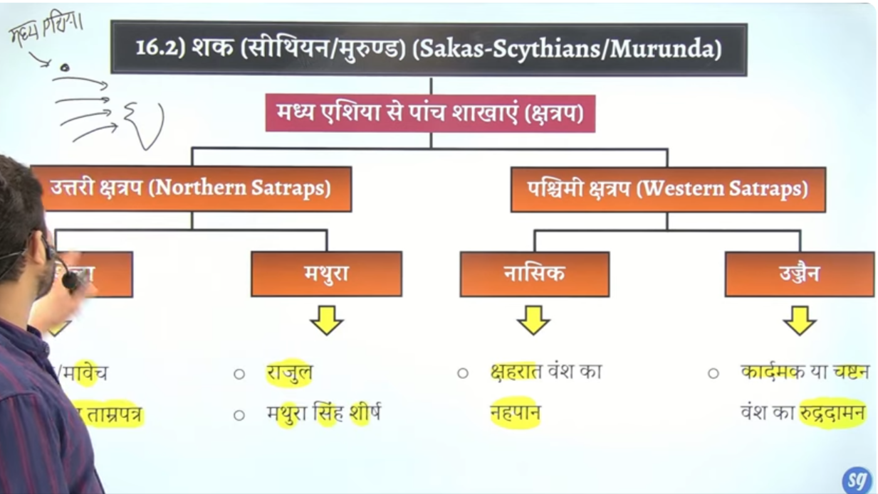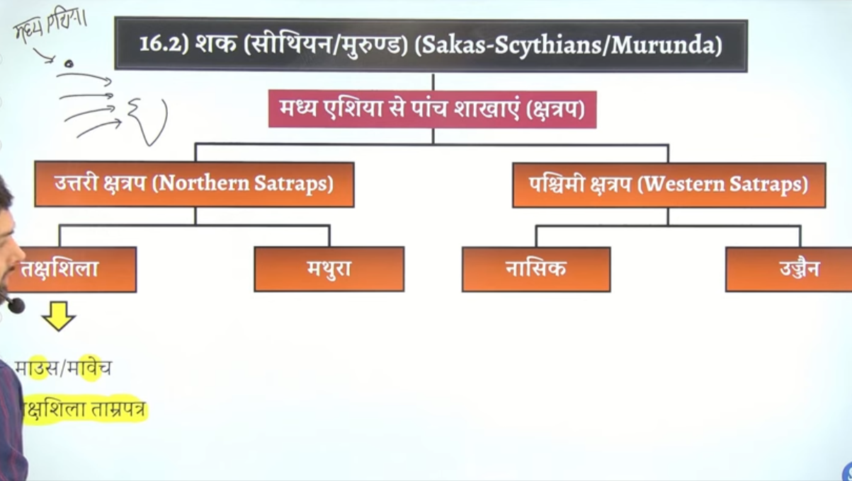

Shakas jo hai wo central asia se bharat aee the
Ye panch alag alag branch me ek sath india aee the aisa nahi tha ko koi ek king akele aya hao jisme ekbranch Videsh o me he rahe the use ko lena dena nahi hai
Remaing char india aee the fir chark ko do bhago me bata gayay tha

Western chatrpa menas naskiper sharatha vansh ka shahsan tha aur Ujjain per kardamak ya chasten vansh ne shdhsn kyia tha kardam, chasten dynasty

Taksheel me ek shaka raja jtha maouse jiske jankari hume tamrpatra taksheela se mitle hai iske bare me sirf thoda he padna hai bas
Taksheela copper inscritpon

Mathura k- shaka me important tha rajul jiske information Mathura singh sirsha se milte hai
Nasik me charaaht vansh ka shaahk tha jisme nahpaan sabse bada king tha
Ujjain me kardamak ya chasten vansh ka shaan tha jisme importna kig tha rudrdaman
Rudradaman ne girnar Junagarh me girnar incriton banwaya jo sanskrti mi likha hua first inscittpon hai aur kavya shaile me likha sabse bada abhelekh hai aur us abhelekh se hume Sudarshan jheeel ke bare me jankari milte hai ki Ashoka ke governor pushagupta vashya ine uska Nirman karay tha

Rudradaman aur age jakar gutpa rjaja skiandgupta ne bhe uska jirodhar karwaa tha rejunvination kyia tha
4
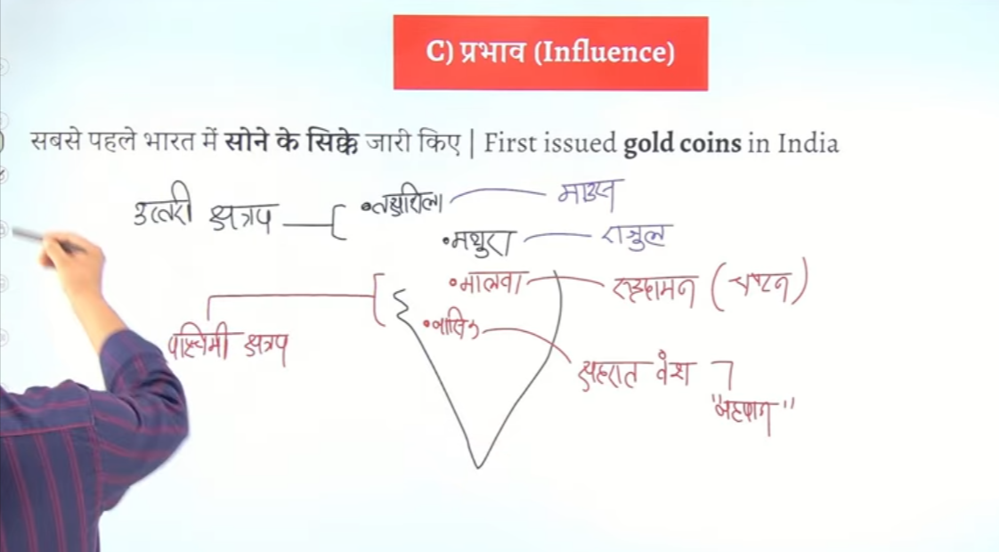

Chatrap ke vyavysth perisn india lekar aee the
But ikso implement sahe se shakas ne kyat ha
Alag lag rajyon ke lye state k lyie chatrap word use kyat ha persain ne

First shaka rajaj maouse ko mana jata hai

Charahart vansh ke shashk napaaan ko satvahan rjaj ne aharyay tha defeat kyia tha

Mathura ke sahak
Main rajaj tha rajul isne he indo Greek ruler ko defeat kyia tha ism eke aur main shahsk hua shodas ye notrhet
Shatrap the
Northern area me inka empire tha

Kahah jata hai ke shako ne Ujjain per akraman kyia lagbhag 57bce me inhone Ujjain per attack kyai tha us samay Ujjain ka ek shashak hua kart tha vikramadyiata vikramadyit ane ya kyia tha shako ko hara dyia tha vikrmadyai ek chetrya regional kig tha tb se
Vikarmadyi us samay ke sabse bade upade title hog ae the
Kuki ek chetrya rjajjisne vedeshoin ko hara dyia tha
Bharta me 14 king aeis hue jionhone vikramdyit ka title lyia tha jisme sabse Jayda prashed shahsk chadngutpat second the jinhone vidkarmadyati ke upade le the

Aur jb 57BCe ko vikramdayi ne shako ko harya tjb Ujjain ke vikramdayi ne shurta ke Vikram Samvat ke jisko malva Samvat bhe bolte hai

Ye pure Kahane hume jain text kalkacharya se milte hai
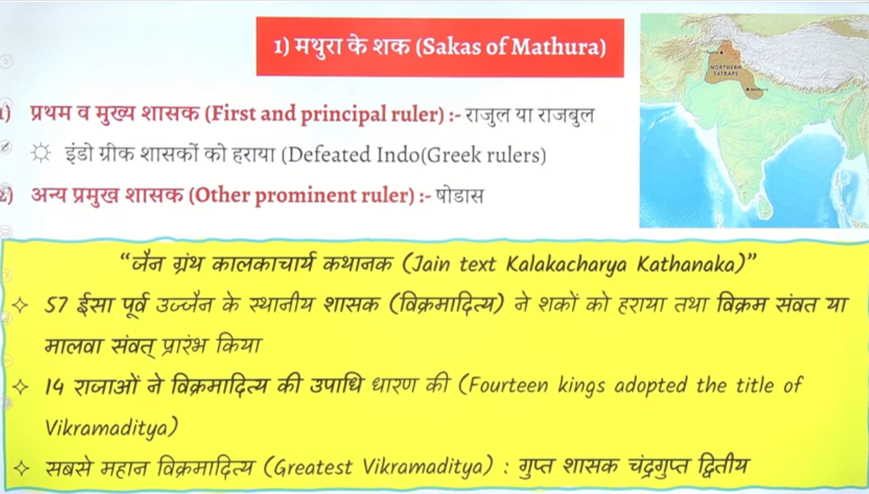

Kardamak ya chasten vansh
Chasten isley naam dyai jata hai kuki is vansh ke pahle king chasten he the jine knaam per is vansh ka naam chastna padat tha

Last ruler rudrasena third ko chandrtupt second hara denge tb wo malva wale cheta me chandi ke sikke jare karnege jo vyagra shaile me bane honge
Q kisko harane ke baad chandrgaupt second ne malva Chetra me chandi ke sikke jare kyia tha to answer shak rajaj rudrasena third ko harne ke baad inohone malva cheta me chandi ke sikke jare kyia tha

Rudramand ke abhelekh me intan he nahi uske sare yudh aur nityaon ke bare me bhe batya gyay hai
Jungarh inscirtpin kis bhaahs me liha hai to answer is Sanskrit bhasa me kis lipi me liha hai to brahmi me aur ye poetic style kavaya shaile me likha gyay hai

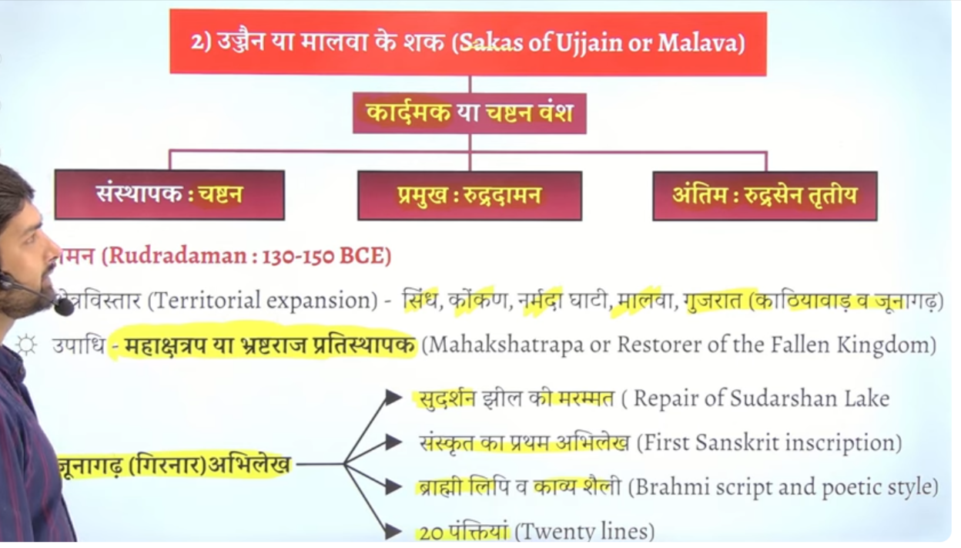

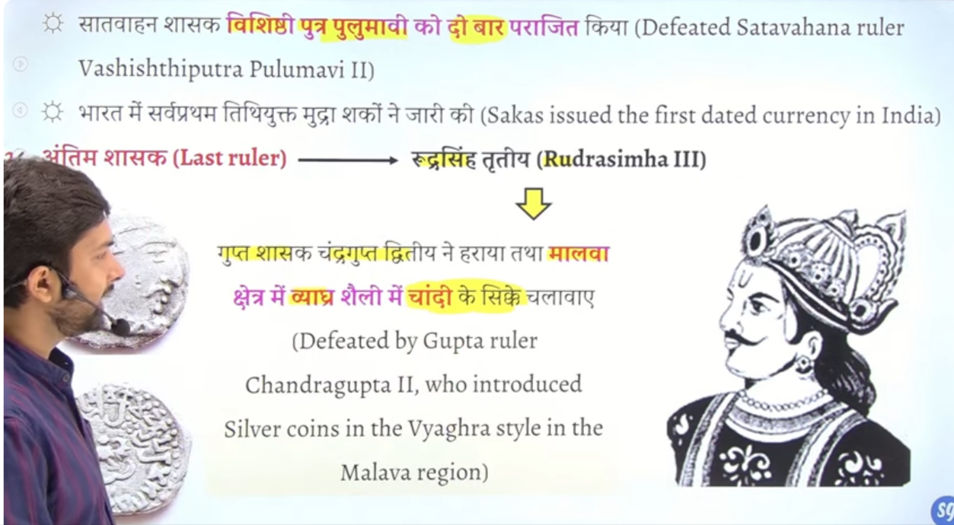

Fir baad me pulvami ke beti se shadi karke aur dono ke beech shandi hog ae the

Bharat me sabse pahle dated currency ko first time issue kyai tha Sychtinan means shakas
Bharat me sabse pahle coin lekare ayet the persian but unhko historian consider nahi karte kuki unhone systematic tareke se pure inda per rule nahi kay aur
Fir indo Greek ne sabse pahle gold coin issue kyai systematic roop se +Coin image +name
But Kushan ne sabse ache quality ke gold ke coin bharat me sabse shudh sone ke sikke jare kyia inhone kaam matra me coin issue kyia but Sudha quality gold ke best rakhe tha

Aur sabse adhik matra me gold coin issue kyai tha guptas ne gupta ke samay numbe of gold coins Jayda milte hai
Dated coin issue = shakas

